# Title Page

Savvy

**User Manual**

**Web-Development**

**Version: 1.0**

**Date: 02/11/2020**

**Inspire the world and create more possibilities.**

‘

**By**

**Pragati Gupta,**

**Tejaswi Kukalakunta,**

**Vishali Gummadi**

# Abstract

Savvy allow you to organize units of related materials that instructor can access from any device with an internet connection. Organized content makes great stand-alone resources—review materials, videos, images, self-paced activities such as quizzes, assignments, grades, discussion, test and create module for students.

# Table

Contents

Table: 2

Introduction 4

Sign up: 7

Login: 8

Dashboard: 9

Module: 11

Assessment: 17

Grades: 25

# Features Successfully Added/ Extra Points

1. Savvy can allow instructor to upload a file (they upload the file in a specific format) and **automatically** populate questions and answers so that instructor doesn’t have to enter questions or answers one at a time in a test creation interface. This will speed up the creation of an online test. This application parse the documents uploaded by the instructor and retrieve the questions and answers contained in this file and process them and then store these into backend database.
2. Dashboard Page: Professor’s name is displayed on the dashboard screen (While sign-up user needs to enter his\her name that will be stored in database. At the home screen it will displayed).
3. Type of questions:
   1. Multiple choice questions
   2. Fill-in the blanks
   3. Match the following
   4. True-false
   5. Short answers
   6. Essay questions
4. In savvy, at Quiz page we used “**hidden function**” so when the professor will click any type of questions (Multiple choice questions, Fill-in the blanks, Match the following, True-false, Short answers, Essay questions) he will see only that kind of question templets to create the exam, user can again select different type of questions and create the question paper with many types on question pattern.
5. In Savvy we use try and catch to detect the error.
6. Notification alerts; displayed where any module or test created.
7. Any module which is already created under a course. System won’t allow to create same name module again.
8. Savvy has
   1. Sign up page
   2. b. Login-page

c. Dashboard page

* Courses
* Modules
* Assessment
  + Discussion
  + Assignment
  + Quiz
    - Create quiz/test
    - Automatic question answer creates, when professor will upload the file
  + Grades page

## YouTube Link

You Tube Video

Link**:** [**https://youtu.be/a9zcEQG_67A**](https://youtu.be/a9zcEQG_67A)

**History**

|  |  |  |  |
| --- | --- | --- | --- |
| **Version** | **Description of Versions / Changes** | **Responsible Party** | **Date** |
| 1.0 | Initial version | Pragati Gupta | 10/17/2020 |
|  | Added Entity Data Model diagram | Tejaswi | 10/20/2020 |
|  | Wireframes | Vishali | 10/20/2020 |
|  | Prototype | Pragati | 10/25/2020 |
|  | Coding | Pragati , Tejaswi ,Vishali | 10/26/2020 |
|  | Testing | Pragati , Tejaswi ,Vishali | 11/02/2020 |

# Introduction

Savvy is an online learning system framework for instructors.



This system facilitates the creation of online learning materials. This online learning system framework supports:

1. Module creation (create different learning modules)
2. Topic creation (create topics under each module)
3. Assessment creation (for instructor to create tests, assignments)
4. Instructor can test run the tests created (like in student view).

This web-based learning system framework will allow instructors to create any online learning system.

# Sign up

To sign up to the application user need to click the **Sign up now** link on the Login page.

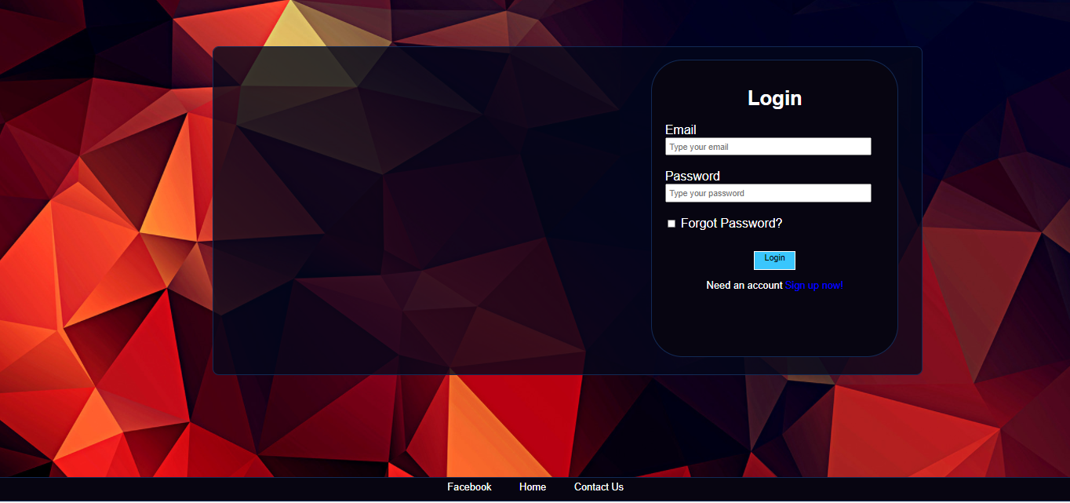

User can enter their email ID, Password and name at the sign-up portal and hit the submit button.

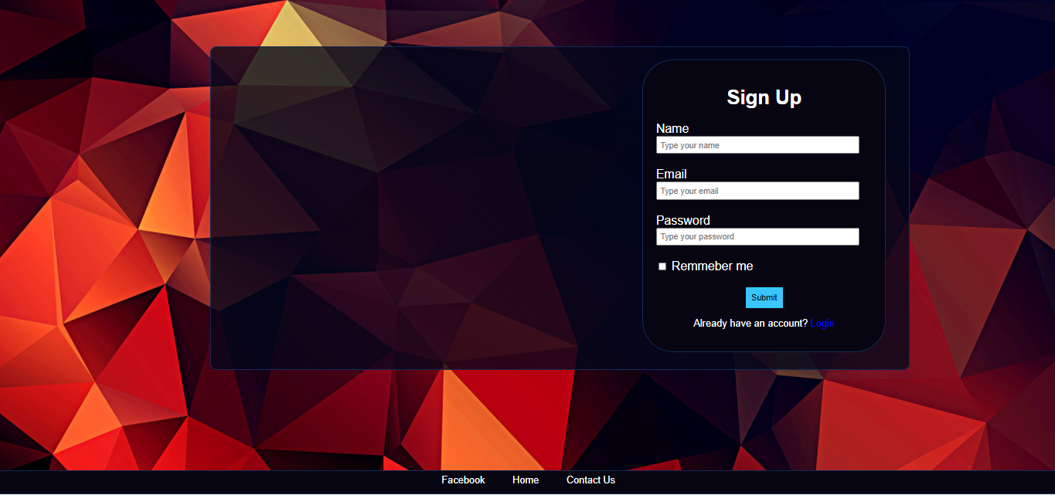

Once you hit the submit button, if the registration is successful then user will be redirected to Login Page

# Login

Login page that will only allow registered user (instructors) to login to create an online learning environment for their course.

To login to the application user need to provide the email id and password which is provided at the time of registration.

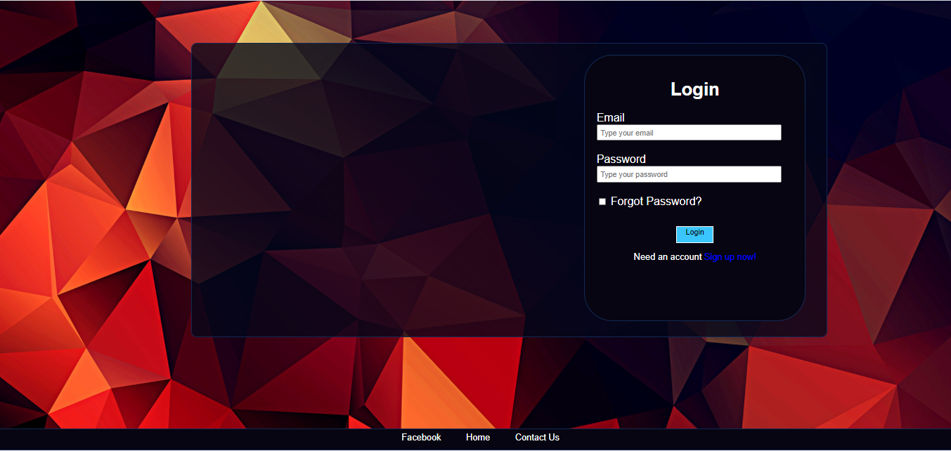

# Dashboard

Dashboard provides the central page to navigate to all the functionalities of the application. It also displays the user name on the top right corner.

Dashboard has three sections.

1. Professor can see the courses assigned to them.

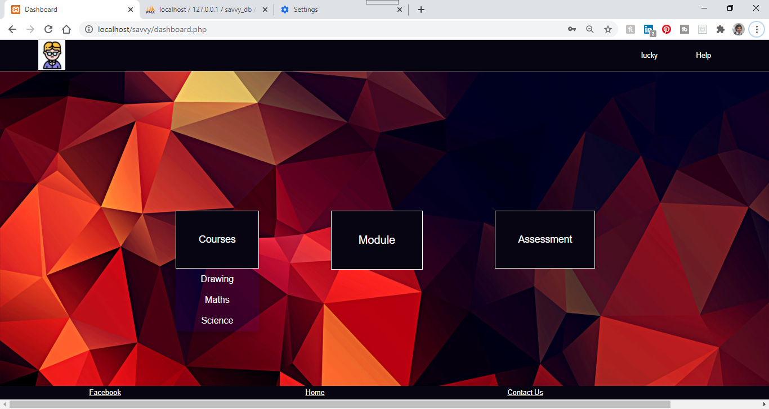

1. Professor can go hover the module section to create modules or view modules

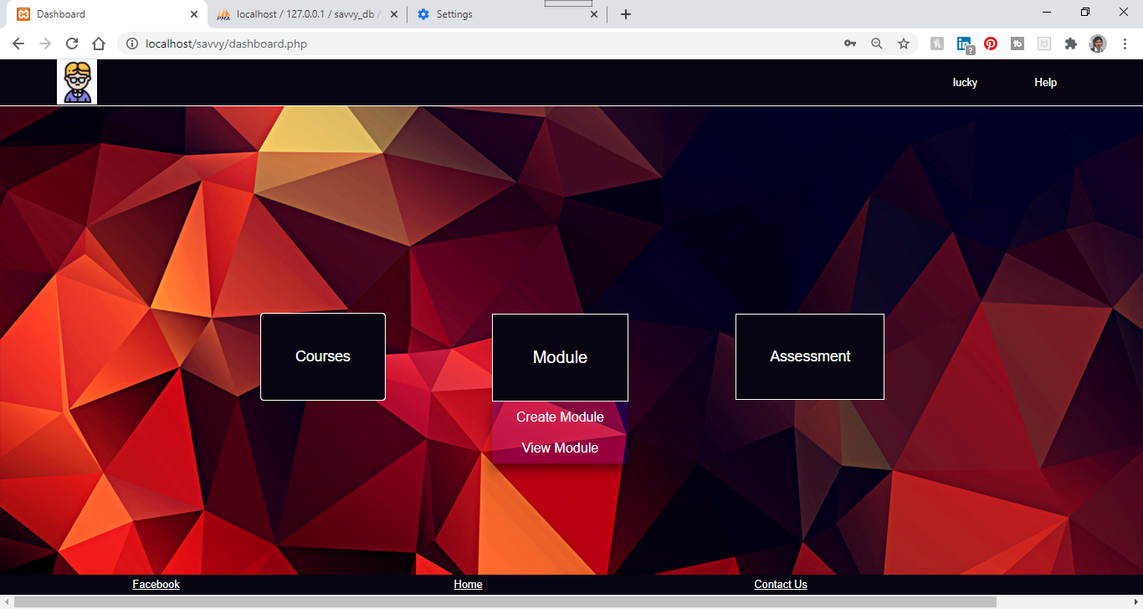

1. Professor can hover the assessment section to create assessment or view assessment or view Grades

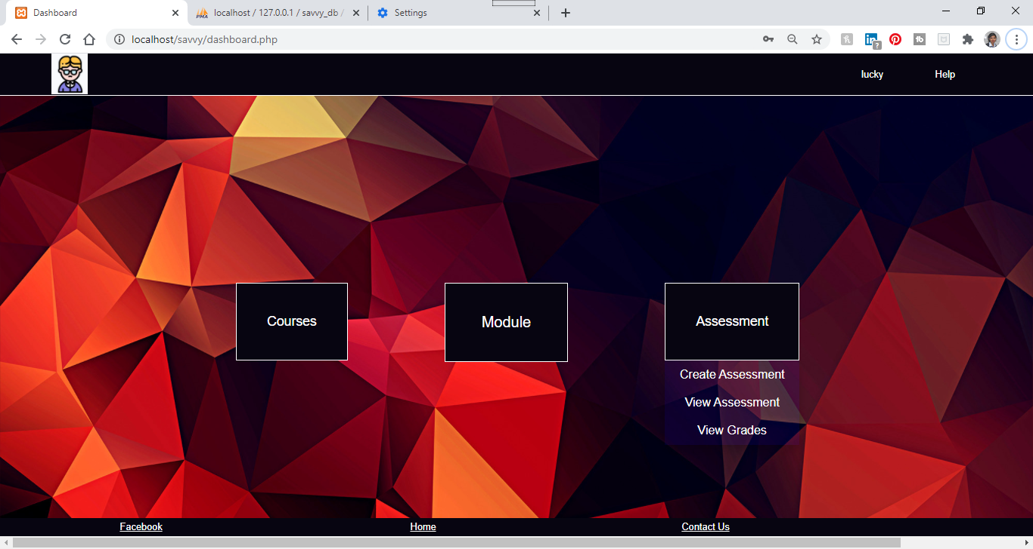

# Module

There are two options to the Module menu, one is Create Module and other is View Module.

1. Create Module:

User can click on the Create Module sub menu to go to the Create Module page.

Course names are auto populated on the create Module page based on the courses assigned to the professor.

User need to provide Module Name which is a mandatory field and then can provide the options fields which are Topic Name, any online URL or user can upload any file such as PDF, word doc for the module.

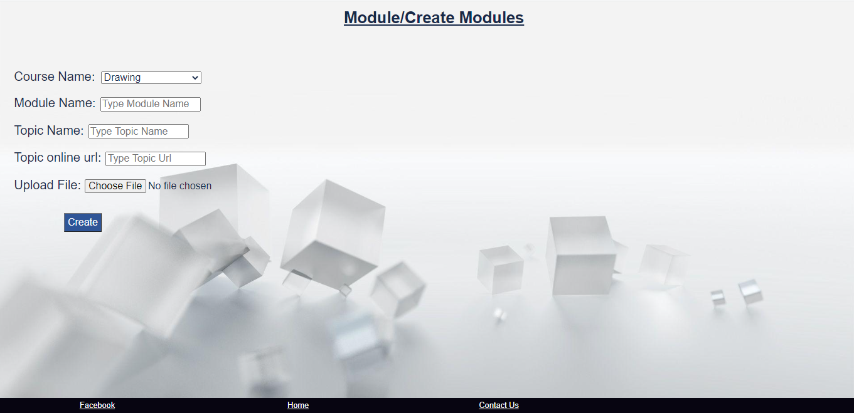

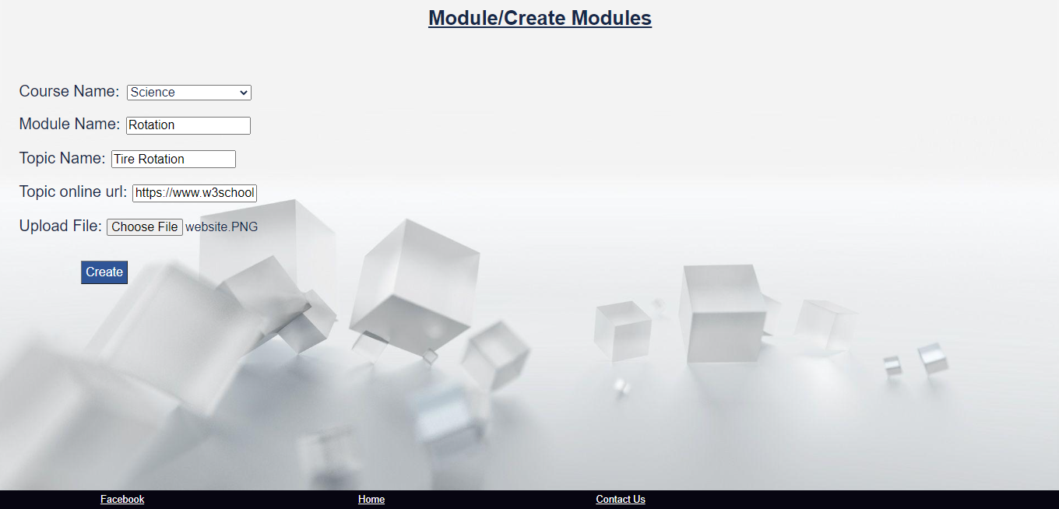

If user click on Create button without providing the Module Name, it will give below error:

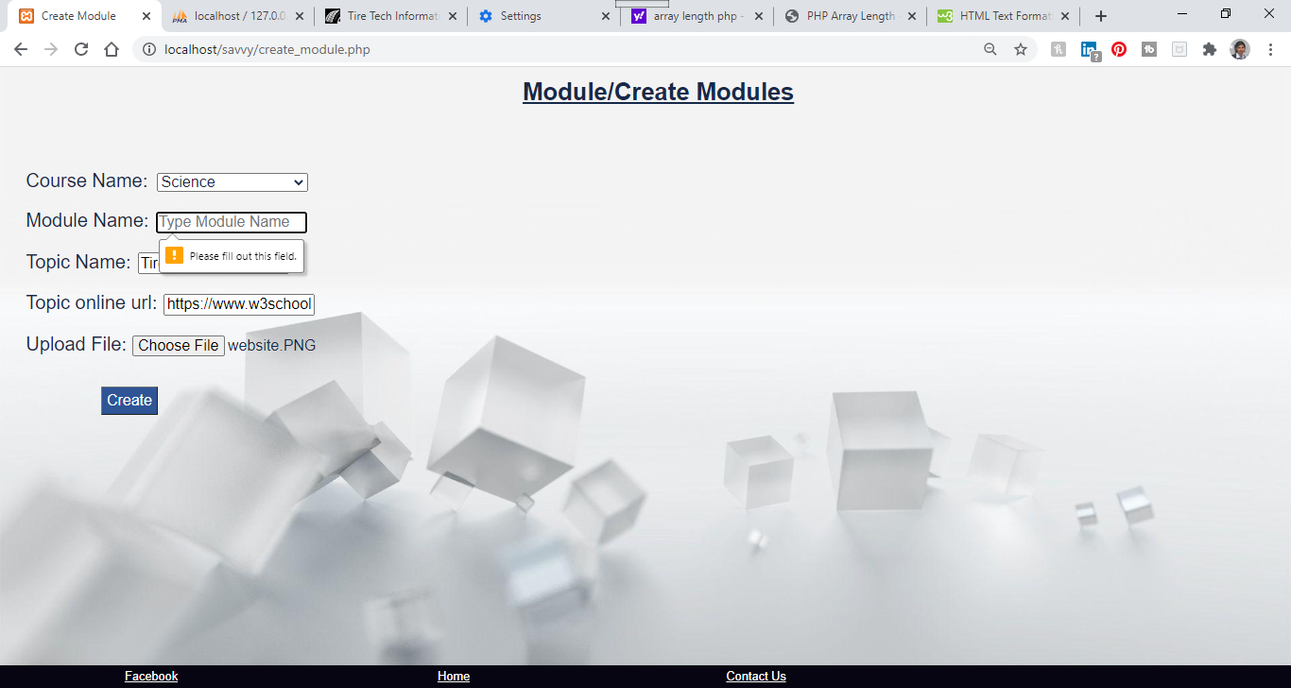

Once the module is successfully created the application will redirect the user to View Module page.

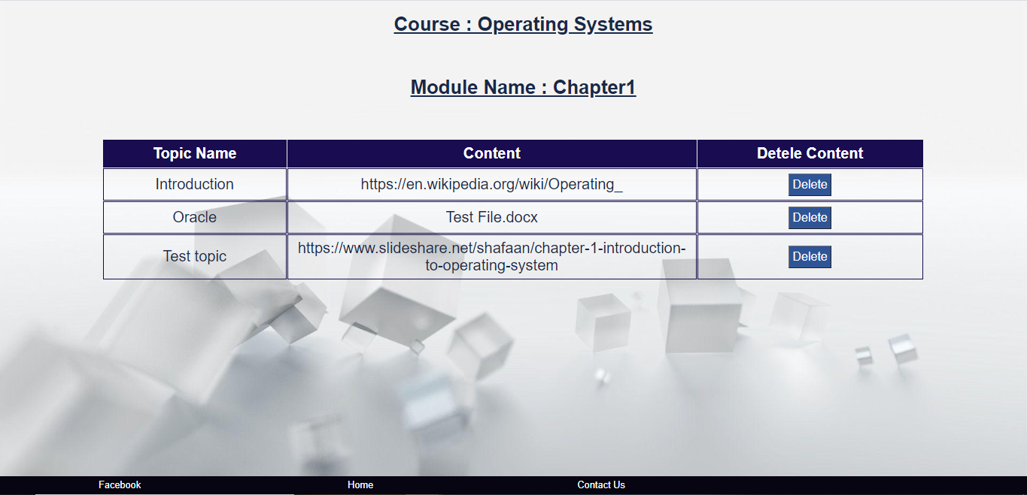

1. View Module:

User can also go to the View Module by clicking on the View Module button on the dashboard in the Module section. First user needs to select the Course Name on the View Module page and then click the Get Module Button to fetch the list of Modules.

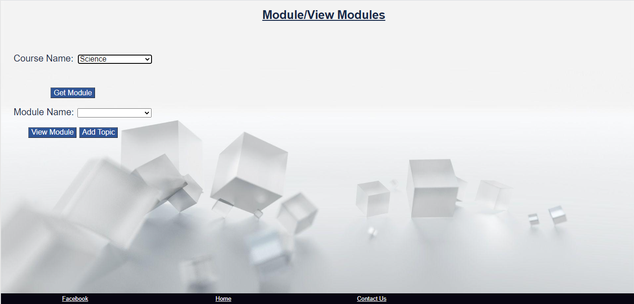

After hitting the Get Module, user will get the list of modules for that course

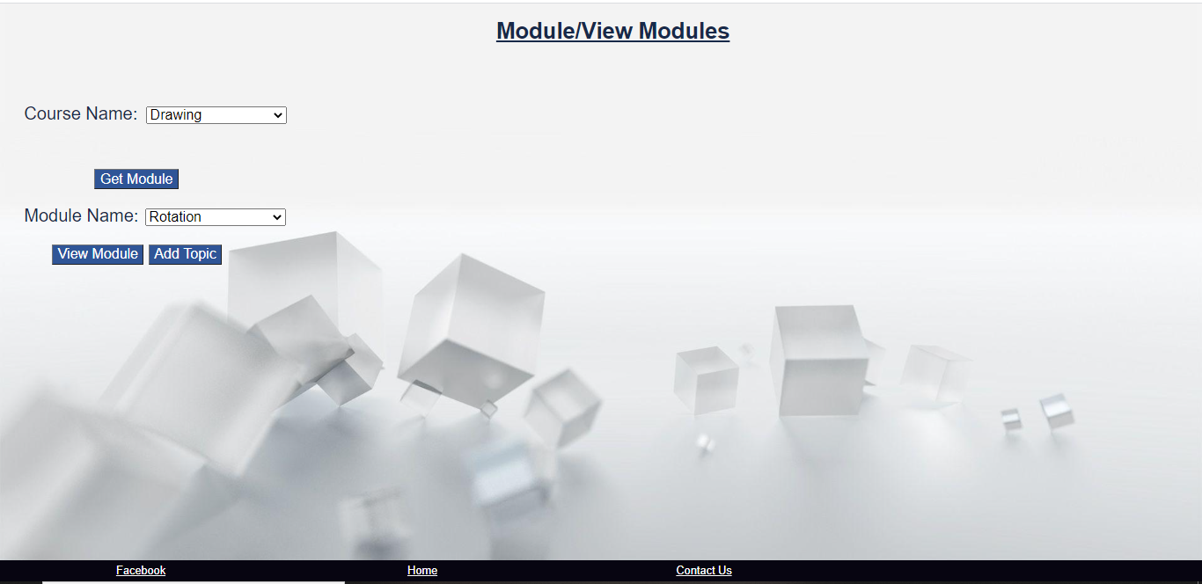

Once user get the list of modules, there are two options:

* View Module button:

With View Module user get the details of the modules with all the topics and the contents added in that module.

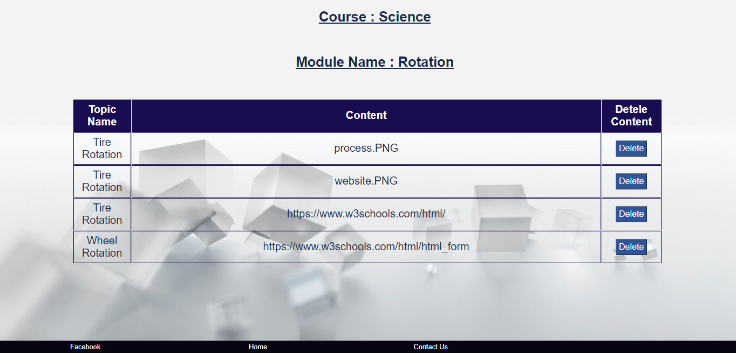

User can also delete any content if required by clicking on the delete button

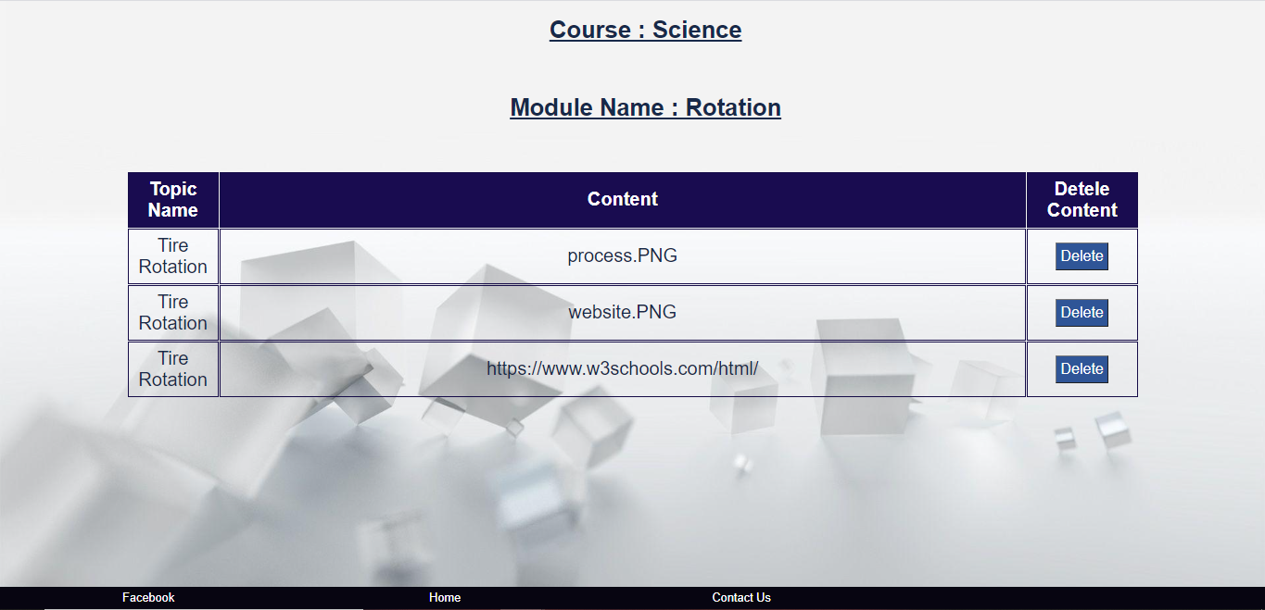

* Add Topic

By clicking this button user will be navigated to the Add Topic page for adding topic to the existing modules by providing the contents

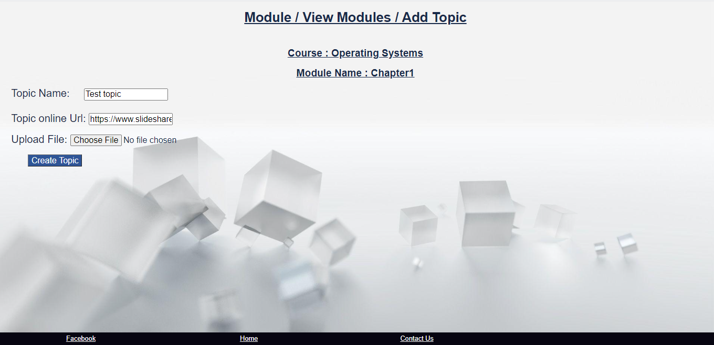

Once you click on Create Topic, the application will create the topic with the url or file uploaded and redirect the user to View Module.



# Assessment

The assessment section has three sections: Create Assessment. View Assessment and View Grades

1. Create Assessment:

User can click on the Create Assessment sub menu to go to the Create Assessment page on the Assessment tab.

Course names are auto populated on the create Assessment page based on the courses assigned to the professor.

Then user need to select the Assessment Type and click on Create Assessment button to go the respective Assessment page.

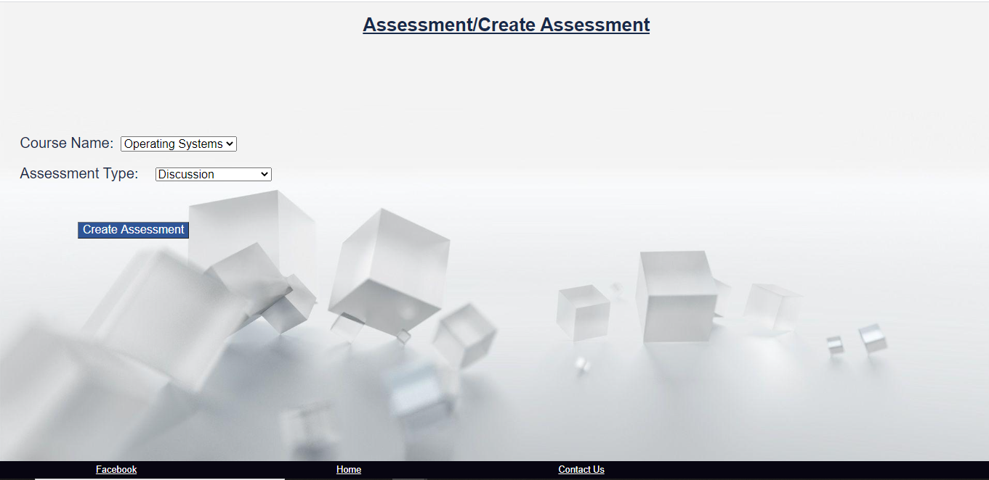

* Assessment Type: Discussion

If user select the Discussion as the assessment type, the application will be redirected to below page where user can create Discussion for the students.

Course name will be auto populated and user need to enter the Discussion name, total score, due date for the assessment and the Question.

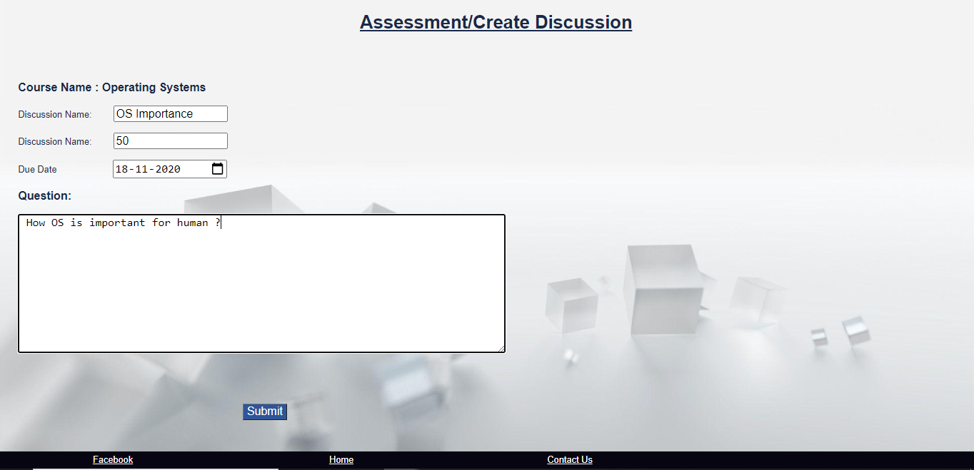

Once the information is entered, user can click on Submit button to submit the discussion.

On successful submit the application will be redirected to View Discussion page.

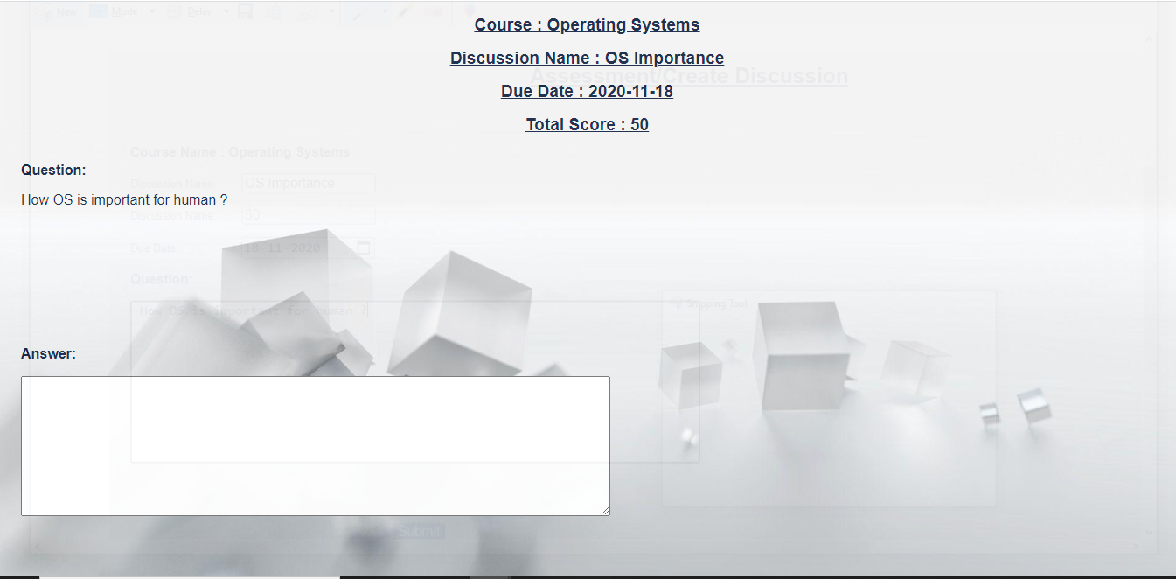

* Assessment Type: Assignment

In the page user can upload the assignment in any format and enter the necessary details such as the name, total score and due date.

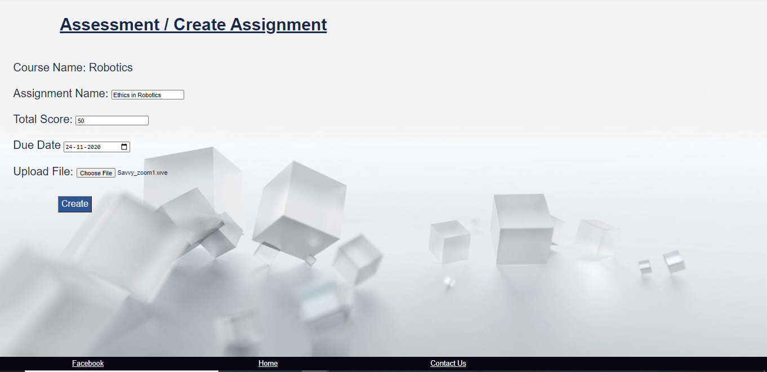

* Assessment Type: Quiz

This page provide user to create the quiz for any course. There are two options for the user once is to create quiz by using the application GUI or user can upload the file in the txt as per the template provided.

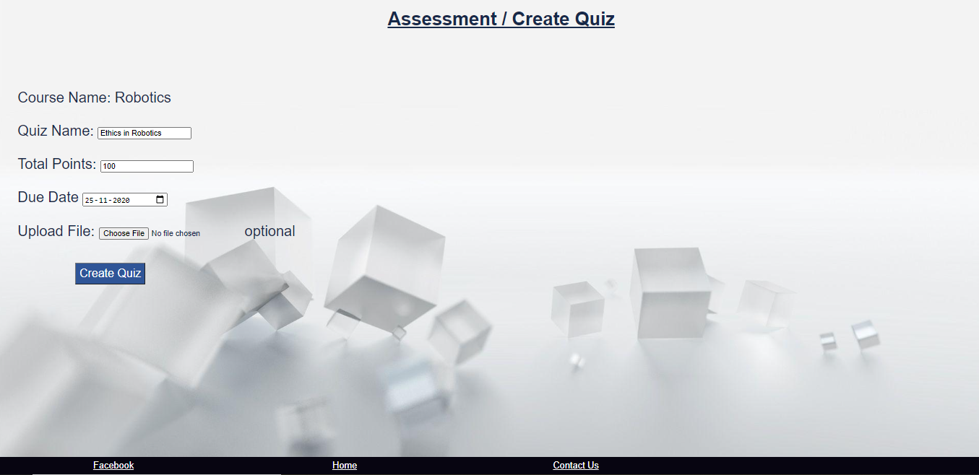

a) If user opt to create the quiz using the application GUI, they just need to provide the quiz name, total score due date and hit the Create Quiz button, the application will be redirected to below page:

After the User can select the Question type to add the question and provide the Question in the space provided. Depending on the question type it will provide the User Interface to add the Answers.

For ex: For Multiple-choice user will get below page:

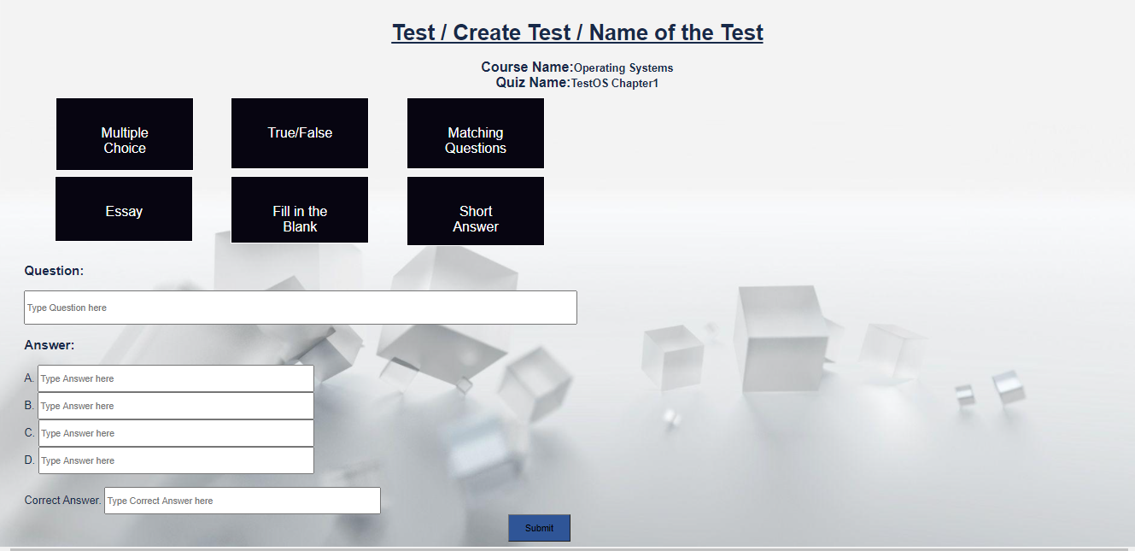

True/false

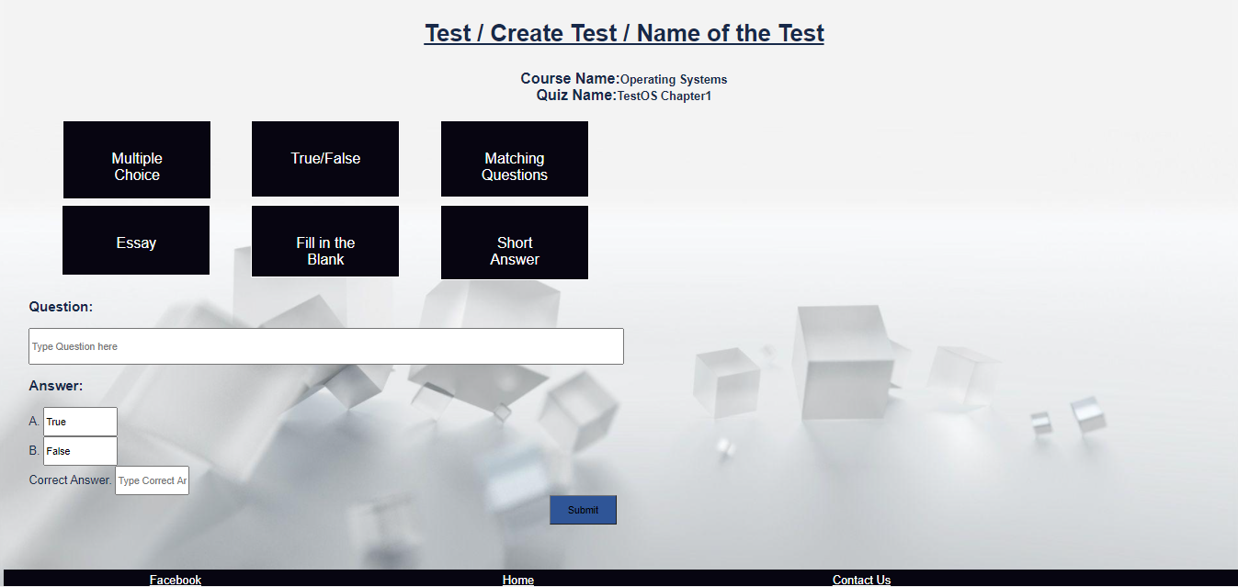

User can submit each question selected and then keep on adding.

This way user can add any type of question for a quiz.

User can go the View Assessment section on the dashboard to see the quiz.

1. If user opt to upload the quiz with the template provided by the application.

User can also create a quiz by uploading the quiz file in txt format with below template.

* The question should start with the **Question**, it can be multiple lines.
* The option to the question should start with **Option,** it can be multiple lines.
* The correct Answer should start with **Correct Answer**

Below is the example for couple of questions, once is having 4 choices and other is having 2.

Question1: SELECT __________FROM instructor WHERE dept name=’Comp. Sci.’;

Which of the following should be used to find the mean of the salary? is it avg (salary

Option1: True

Option2: False

Correct Answer: Yes

Question2: SELECT COUNT (____ ID) FROM teaches WHERE semester = ’Spring’ AND YEAR = 2010;

If we do want to eliminate duplicates, we use the keyword ______ in the aggregate

Option1: Distinct

Option2: Count

Option3: Avg

Option4: Primary key

Correct Answer: Distinct

User can upload the file in above format and click on Create Quiz

User will be redirected to the view quiz

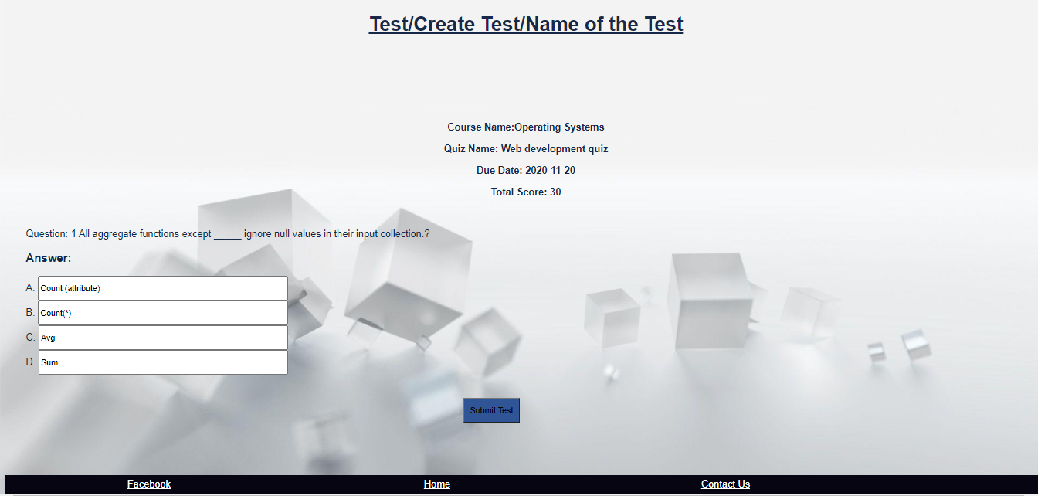

1. View Assessment:

User can directly go to the View Assessment page by clicking the View Assessment in Assessment section on dashboard.

First user needs to select the course name, Assessment type and hit the get Assessment to get the list of Assessment:

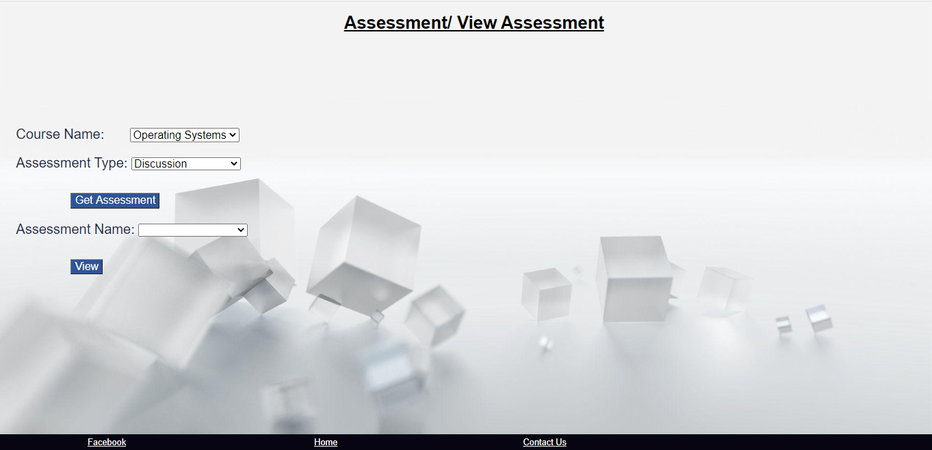

Then user can select the Assessment Name from the list and click on View to get the details

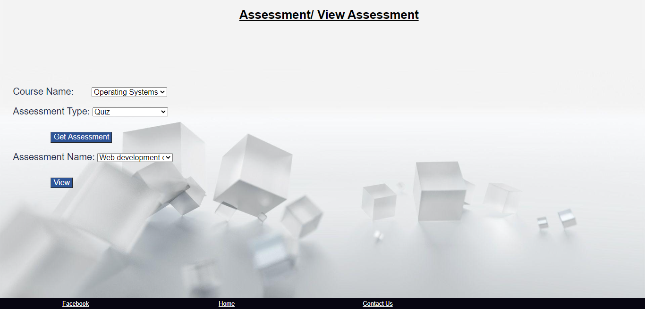

Depending on the Assessment type user will get different view.

Quiz:



Discussion:

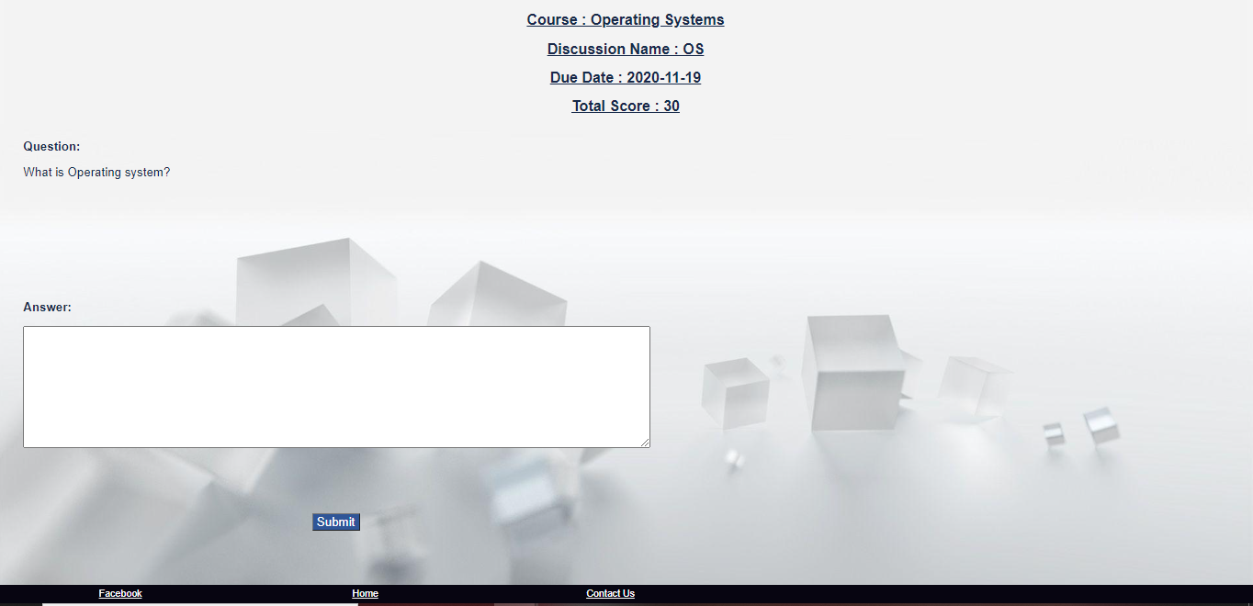

Assignment:

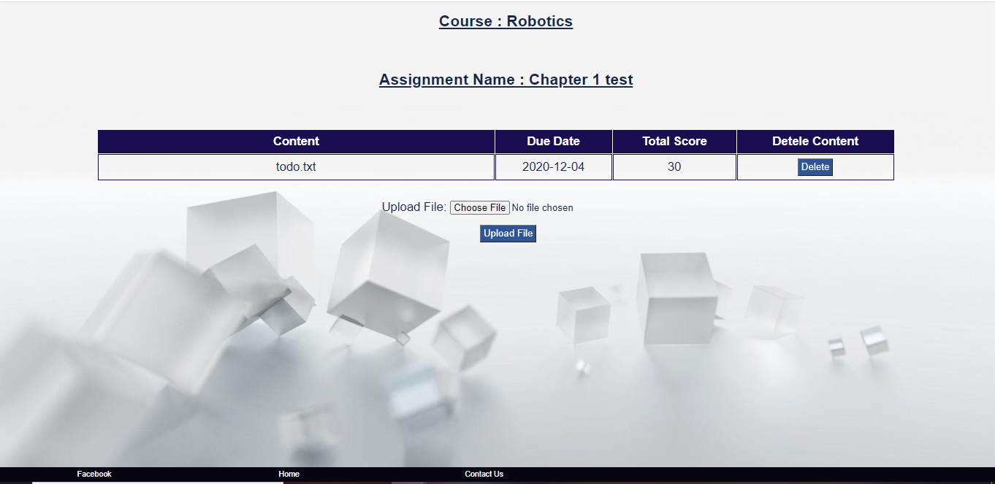

# Grades

Display assessment statistic for student at the end of an online test (e.g., how many questions wrong and how many rights etc.).

User can view the grades in, View grades option under Assessment section. On the View grades page user need to select the course name and Assessment Type from the dropdown. Submit the request by hitting Get Assessment button. Then select the Assessment Name form the dropdown and hit “View Grades”

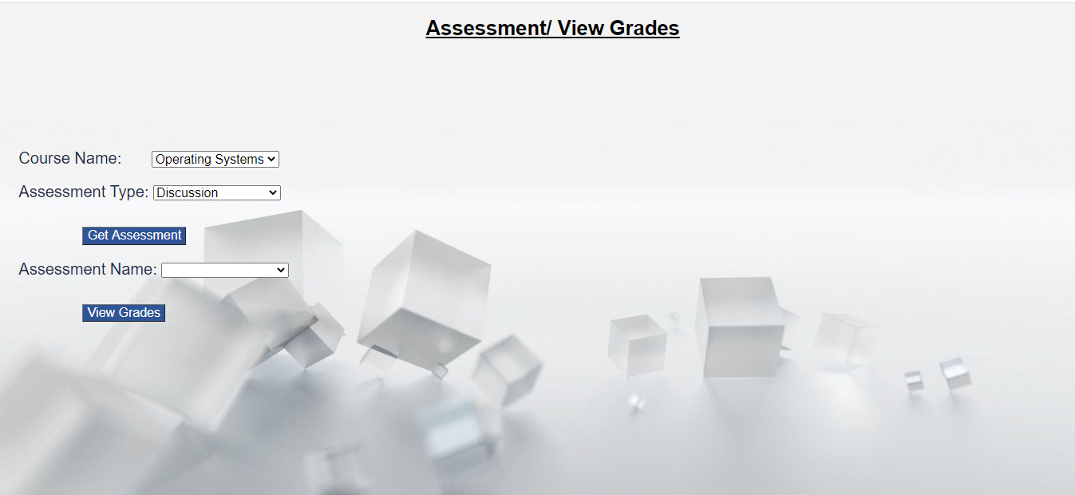

Next page is displayed with the course name, assignment name both are read only. In the grade table instructor can view the student name, Total no of Questions, Correct Answers, Incorrect Answers and Grade.

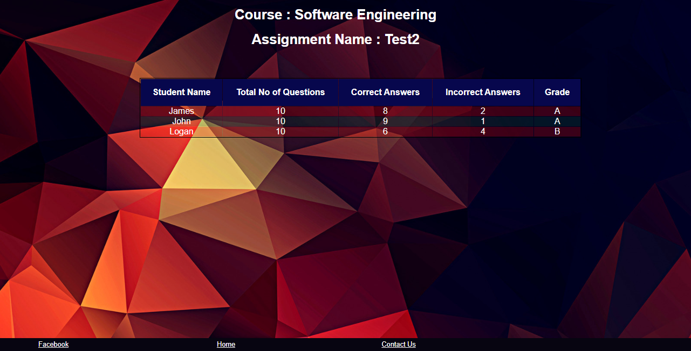

Savvy: Inspire the world and create more possibilities.

## Thank you